ROHM Switching Regulator Solutions

Evaluation Board:

Synchronous Buck Converter

Integrated FET

BU90006GWZ-E2EVK-101 (3.0V | 1A Output)

No.000000000

* Introduction

This application note will provide the steps necessary to operate and evaluate ROHM’s synchronous buck DC/DC converter using the BU90006GWZ evaluation boards. Component selection, board layout recommendations, operation procedures and application data is provided.

* Description

This evaluation board has been developed for ROHM’s synchronousbuck DC/DC converter customers evaluating BU90006GWZ. While accepting a power supply of 2.3-5.5V, an output of 3.0V can be produced. The IC has internal 250mOhm high-side P-channel MOSFET and 220mOhm low-side N-channel MOSFET (at VIN=5V) and a synchronization frequency range of 5.4MHz to 6.6MHz. A fixed Soft Start circuit prevents in-rush current during startup along with UVLO (low voltage error prevention circuit) and TSD (thermal shutdown detection) protection circuits. An EN pin allows for simple ON/OFF control of the IC to reduce standby current consumption. A MODE pin allows the user to select Forced PWM (Pulse Width Modulation) mode or PFM (Pulse Frequency Modulation) and PWM auto change mode utilized power save operation at light load current.

* Applications

Smart phones, Cell phones, Portable applications and Micro DC/DC modules, USB accessories

* Evaluation Board Operating Limits and Absolute Maximum Ratings

|  |  |  |  |  |  |  |  |
| --- | --- | --- | --- | --- | --- | --- | --- |
| **Parameter** | | **Symbol** | **Limit** | | | **Unit** | **Conditions** |
| **MIN** | **TYP** | **MAX** |
| **Supply Voltage** | | | | | | | |
|  | BU90006GWZ | V­CC | 2.3 | - | 5.5 | V |  |
| **Output Voltage / Current** | | | | | | | |
|  | BU90006GWZ | VOUT | - | 3.00 | - | V |  |
| IOUT | - | - | 1 | A |  |

* Evaluation Board

Below is evaluation board with the BU90006GWZ.

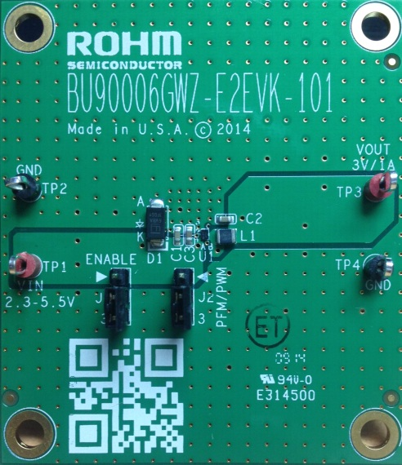

Fig 1: BU90006GWZ Evaluation Board

**Vout**

**GND**

**EN**

BD9673EFJ Eval Board

* Evaluation Board Schematic

Below is evaluation board schematic for BU90006GWZ.

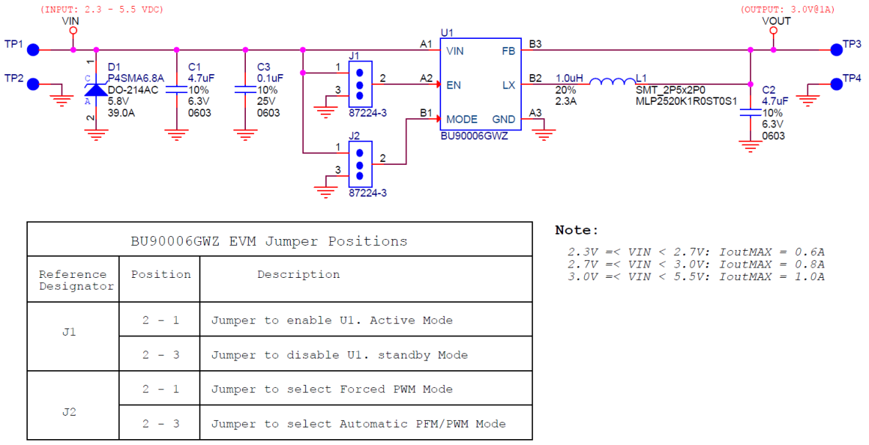

Fig 2: BU90006GWZ Evaluation Board Schematic

* Evaluation Board I/O

Below is reference application circuit that shows the inputs (VIN, EN and MODE) and the output (VOUT).

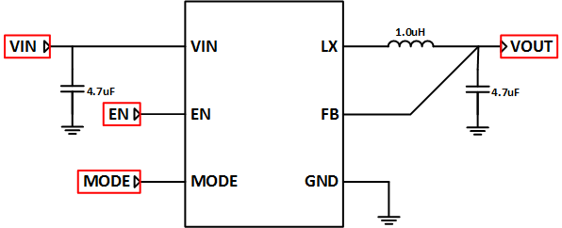

Fig 3: BU90006GWZ Evaluation Board I/O

* Evaluation Board Operation Procedures

Below is the procedure to operate the evaluation board.

1. Connect power supply’s GND terminal to GND test point TP2 on the evaluation board.
2. Connect power supply’s VCC terminal to VIN test point TP1 on the evaluation board. This will provide VIN to the IC U1. Please note that the VCC should be in range of 2.3V to 5.5V.
3. Set operation mode of IC by set position of shunt jumper of J2 (If Pin2 connect to Pin1, MODE pin of IC U1 will be pulled high and IC U1 will operate in Forced PWM mode, else MODE pin of IC U1 will be pulled low and IC U1 will operate in Automatic PFM/PWM mode).
4. Check if shunt jumper of J1 is at position ON (Pin2 connect to Pin1, EN pin of IC U1 is pulled high).
5. Connect electronic load to TP3 and TP4. Do not turn on load (electronic load is off power).
6. Turn on power supply. The output voltage VOUT (+3.0V) can be measured at the test point TP3. Now turn on the load. The load can be increased up to 1A MAX.

*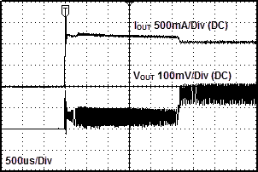Notes*:

Fig 4: IOUT vs. VOUT when OCP active

*In some cases that the evaluation board is not operated following the above power up sequence, the output current spike can exceed the current limitation 1A with electronic load 1A setting as shown in fig.4. Then the integrated OCP (Over Current Protection) will be active to protect the IC and the output voltage is about 0.18V instead of 3.0V as expected.* *In order to get the IC out of*

*OCP, turn off any output loads and power down the input voltage. Then, follow the operating procedure listed above for normal operation of this IC.*

* Reference Application Data for BU90006GWZ-E2EVK-101

Following graphs show hot plugging test, quiescent current, efficiency, load response, output voltage ripple response of the BU90006GWZ evaluation board.

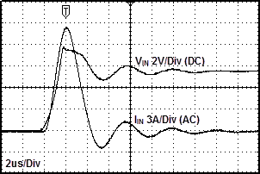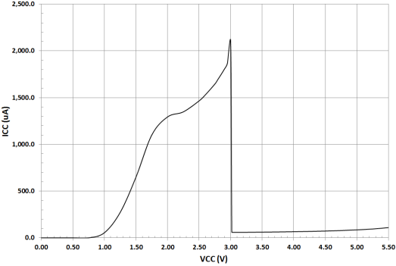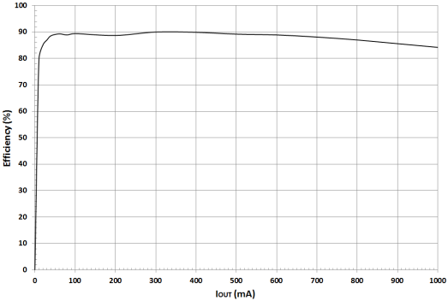

**Fig 5: Hot Plug-in Test with Zener Diode P4SMA6.8A, VIN=5.5V, VOUT=3.0V, IOUT=1A, Automatic PFM/PWM Mode**

**Fig 6: Circuit Current vs. Power supply Voltage Characteristics (Temp=25oC, Automatic PFM/PWM Mode)**

**Fig 7: Electric Power Conversion Rate**

**(VOUT=3.0V, Automatic PFM/PWM Mode)**

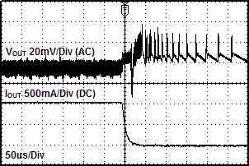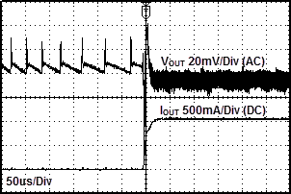

Fig 8: Load Response Characteristics

(VIN=5V, VOUT=3.0V, L=1.0uH, COUT=4.7uF, IOUT=0A🡪1A, Automatic PFM/PWM Mode)

Fig 9: Load Response Characteristics

(VIN=5V, VOUT=3.0V, L=1.0uH, COUT=4.7uF, IOUT=1A🡪0A, Automatic PFM/PWM Mode)

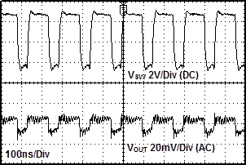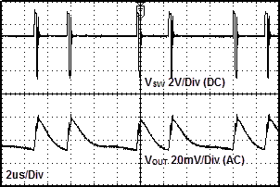

Fig 10: Output Voltage Ripple Response Characteristics

(VIN=5V, VOUT=3.0V, L=1.0uH, COUT=4.7uF, IOUT=10mA, Automatic PFM/PWM Mode)

Fig 11: Output Voltage Ripple Response Characteristics

(VIN=5V, VOUT=3.0V, L=1.0uH, COUT=4.7uF, IOUT=1A, Automatic PFM/PWM Mode)

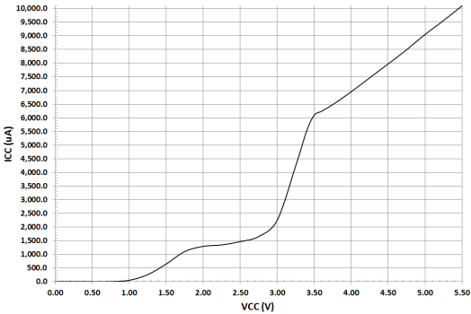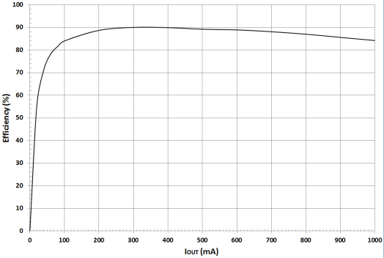

**Fig 12: Hot Plug-in Test with Zener Diode P4SMA6.8A, VIN=5V, VOUT=3.0V, IOUT=1A, Forced PWM Mode**

**Fig 13: Circuit Current vs. Power supply Voltage Characteristics (Temp=25oC, Forced PWM Mode)**

**Fig 14: Electric Power Conversion Rate**

**(VOUT=3.0V, Forced PWM Mode)**

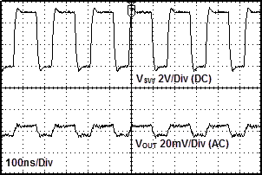

Fig 17: Output Voltage Ripple Response Characteristics

(VIN=5V, VOUT=3.0V, L=1.0uH, COUT=4.7uF, IOUT=10mA, Forced PWM Mode)

Fig 18: Output Voltage Ripple Response Characteristics

(VIN=5V, VOUT=3.0V, L=1.0uH, COUT=4.7uF, IOUT=1A, Forced PWM Mode)

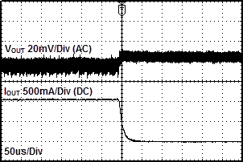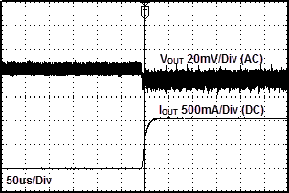

Fig 15: Load Response Characteristics

(VIN=5V, VOUT=3.0V, L=1.0uH, COUT=4.7uF, IOUT=0A🡪1A, Forced PWM Mode)

Fig 16: Load Response Characteristics

(VIN=5V, VOUT=3.0V, L=1.0uH, COUT=4.7uF, IOUT=1A🡪0A, Forced PWM Mode)

* Evaluation Board Layout Guidelines

Below are the guidelines that have been followed and recommended for BU90006GWZ designs.

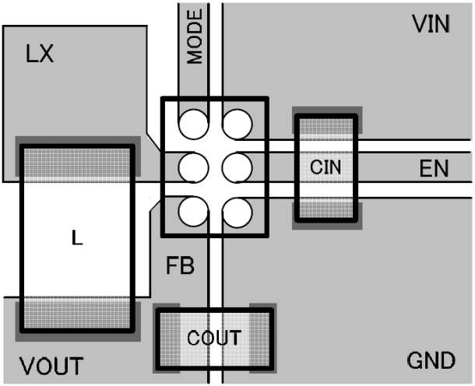

Fig 19: BU90006GWZ PCB Layout

* The input capacitor CIN should be connect as closely possible to VIN pin and GND pin.
* From the output voltage to the FB pin line should be as separate as possible.
* COUT and L should be connected as closely as possible. The connection of L to the LX pin should be as short as possible.

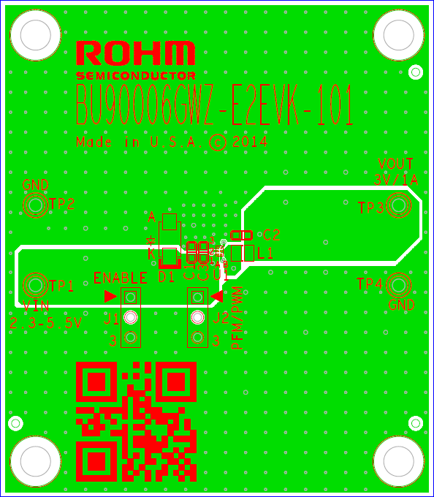

Fig 20: BU90006GWZ-E2EVK-101 Board PCB layout

* Calculation of Application Circuit Components

Selection of inductor (L)

The inductance significantly depends on output ripple current. As shown by following equation, the ripple current decreases as the inductor and/or switching frequency increase.

f: switching frequency, L: inductance, ΔIL: inductor current ripple

As a minimum requirement, the DC current rating of the inductor should be equal to the maximum load current plus half of the inductor current ripples as shown by the following equation.

* Evaluation Board BOM

Below is a table with the build of materials. Part numbers and supplier references are provided.

|  |  |  |  |  |  |
| --- | --- | --- | --- | --- | --- |
| **Item** | **Qty.** | **Ref** | **Description** | **Manufacturer** | **Part Number** |
| 1 | 2 | C1,C2 | CAP CER 4.7UF 6.3V 10% X5R 0603 | Murata | GRM188R60J475KE19D |
| 2 | 1 | C3 | CAP CER 0.1UF 25V 10% X7R 0603 | Murata | GRM188R71E104KA01D |
| 3 | 1 | D1 | DIODE TVS 400W 6.8V UNI 5% SMD | Littelfuse Inc | P4SMA6.8A |
| 4 | 2 | J1,J2 | CONN HEADER VERT .100 3POS 15AU | TE Connectivity | 87224-3 |
| 5 | 1 | L1 | INDUCTOR POWER 1.0UH 2.3A SMD | TDK | MLP2520K1R0ST0S1 |
| 6 | 2 | TP1,TP3 | TEST POINT PC MULTI PURPOSE RED | Keystone Electronics | 5010 |
| 7 | 2 | TP2,TP4 | TEST POINT PC MULTI PURPOSE BLK | Keystone Electronics | 5011 |
| 8 | 1 | U1 | IC REG BUCK SYNC 3.0V 1A 6WLCSP | ROHM | BU90006GWZ-E2 |
| 9 | 2 |  | Shunt jumper for header J1, J2 (item #4), CONN SHUNT 2POS GOLD W/HANDLE | TE Connectivity | 881545-1 |

**Notes**

No copying or reproduction of this document, in part or in whole, is permitted without the consent of ROHM Co.,Ltd.

The content specified herein is subject to change for improvement without notice.

The content specified herein is for the purpose of introducing ROHM's products (hereinafter "Products"). If you wish to use any such Product, please be sure to refer to the specifications, which can be obtained from ROHM upon request.

Examples of application circuits, circuit constants and any other information contained herein illustrate the standard usage and operations of the Products. The peripheral conditions must be taken into account when designing circuits for mass production.

Great care was taken in ensuring the accuracy of the information specified in this document. However, should you incur any damage arising from any inaccuracy or misprint of such information, ROHM shall bear no responsibility for such damage.

The technical information specified herein is intended only to show the typical functions of and examples of application circuits for the Products. ROHM does not grant you, explicitly or implicitly, any license to use or exercise intellectual property or other rights held by ROHM and other parties. ROHM shall bear no responsibility whatsoever for any dispute arising from the use of such technical information.

The Products specified in this document are intended to be used with general-use electronic equipment or devices (such as audio visual equipment, office-automation equipment, communication devices, electronic appliances and amusement devices).

The Products specified in this document are not designed to be radiation tolerant.

While ROHM always makes efforts to enhance the quality and reliability of its Products, a Product may fail or malfunction for a variety of reasons.

Please be sure to implement in your equipment using the Products safety measures to guard against the possibility of physical injury, fire or any other damage caused in the event of the failure of any Product, such as derating, redundancy, fire control and fail-safe designs. ROHM shall bear no responsibility whatsoever for your use of any Product outside of the prescribed scope or not in accordance with the instruction manual.

The Products are not designed or manufactured to be used with any equipment, device or system which requires an extremely high level of reliability the failure or malfunction of which may result in a direct threat to human life or create a risk of human injury (such as a medical instrument, transportation equipment, aerospace machinery, nuclear-reactor controller, fuel-controller or other safety device). ROHM shall bear no responsibility in any way for use of any of the Products for the above special purposes. If a Product is intended to be used for any such special purpose, please contact a ROHM sales representative before purchasing.

If you intend to export or ship overseas any Product or technology specified herein that may be controlled under the Foreign Exchange and the Foreign Trade Law, you will be required to obtain a license or permit under the Law.



Thank you for your accessing to ROHM product information.

More detail product information and catalogs are available, please contact us.

**ROHM Customer Support System**

<http://www.rohm.com/contact/>